Azure Data Platform Proposal for “Paws & Whiskers”
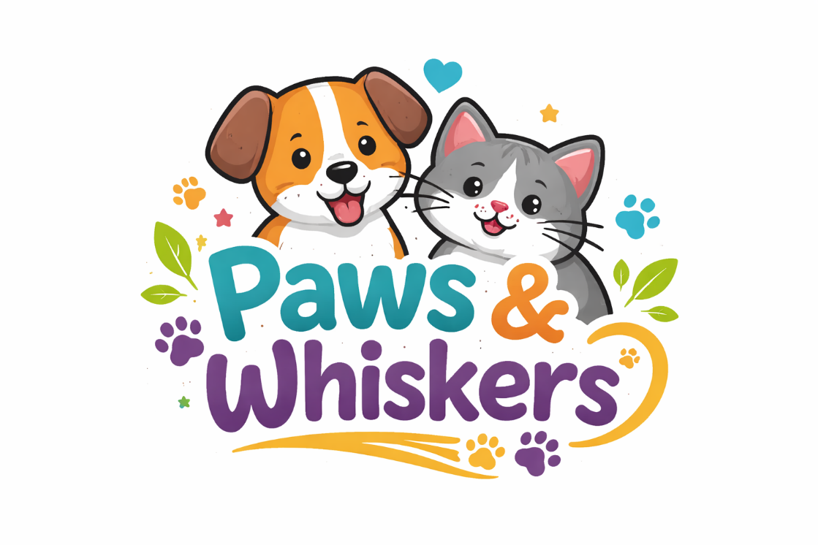
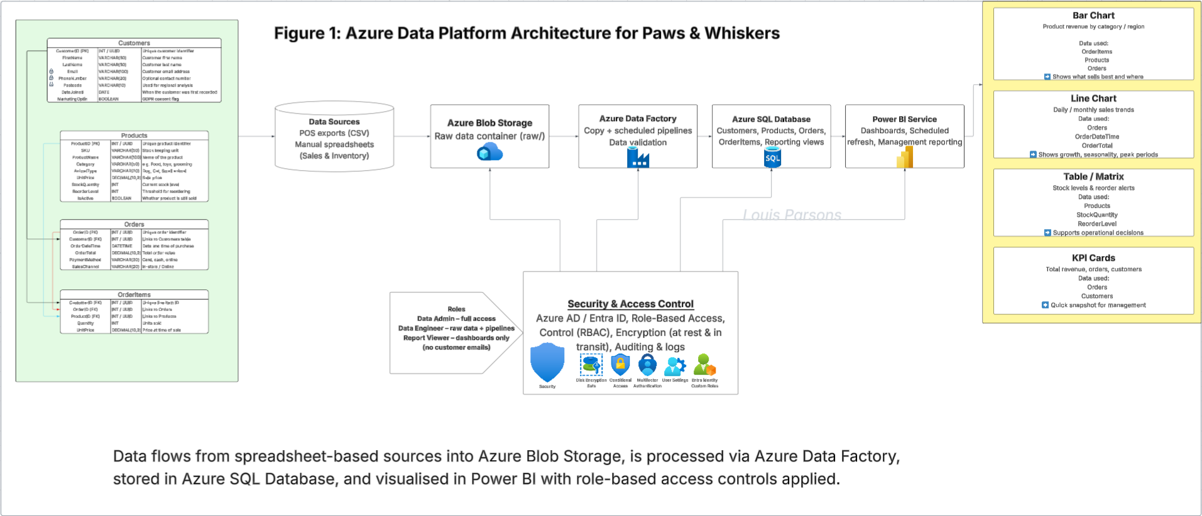

Contents
  - Scenario Background
1.1 Business Context
1.2 Current Challenges and Objectives
  - Data Laws and Regulations
2.1 GDPR Compliance
2.2 Data Protection Act (DPA) 2018
2.3 Other Industry Standards
  - Azure Service Recommendations
3.1 Data Storage Services
3.2 Data Analysis Tools
3.3 Data Integration and Automation
  - Data Types and Data Modelling
4.1 Data Categories
4.2 Relational Data Model
4.3 Analytical / Warehouse-Style Reporting Layer
  - Data Storage Formats and Structures in Azure
5.1 Data Formats
5.2 Data Security and Encryption
  - Additional Considerations
6.1 Backup and Disaster Recovery
6.2 Data Visualisation
6.3 Future Scalability
  - Implementation Guide
7.1 Azure Resource Group and Environment Setup
7.2 Blob Storage Configuration
7.3 Azure SQL Database Deployment
7.4 Azure Data Factory Pipelines
7.5 Power BI Integration
  - Security and Access Control
8.1 Role Definitions
8.2 Access Restrictions by Service
8.3 Auditing and Compliance Support
  - Example SQL Queries and Formulas
9.1 Data Quality Queries
9.2 Revenue and Performance Calculations
9.3 Operational Queries
  - Pricing Considerations
  - References

1. Scenario Background
“Paws & Whiskers” is a growing pet shop that wants to improve business performance by analysing sales, customer information, and inventory data. At the moment, this information is collected manually or stored in spreadsheets. That approach works when there are only a few products and a small number of daily sales, but it breaks down quickly as the business expands. Common issues include duplicated customer records, inconsistent product naming, accidental formula errors, and slow reporting (because someone has to manually combine sheets and “clean” the data before management can see anything useful).
Management’s goal is to transition to Microsoft Azure to streamline data storage, analysis, and reporting. The core value of Azure for this scenario is that it provides a secure, central environment where raw data can be stored safely, cleaned in a repeatable way, loaded into structured tables for reporting, and then visualised in dashboards. Instead of spending time rebuilding the same report every week, Paws & Whiskers can build a pipeline once and then let it run on a schedule.
This proposal covers the legal and regulatory responsibilities around customer data, recommends Azure services that match the business needs, describes the data types and modelling approach, explains storage formats and structures, and outlines additional considerations such as security, backup, reporting, and scalability.

2. Data Laws and Regulations
When Paws & Whiskers stores customer data in Azure, the business remains legally responsible for how that data is used and protected. Cloud storage does not reduce accountability; it just changes where the data lives and how it is managed.
GDPR Compliance
The General Data Protection Regulation (GDPR) applies to organisations processing personal data of individuals in the UK/EU. For Paws & Whiskers, personal data includes customer names, email addresses, phone numbers, addresses/postcodes, loyalty scheme identifiers, and potentially purchase history (because it can be linked back to an identifiable person).
In practice, GDPR affects the platform design in the following ways:
- Lawful basis and transparency: The business must be clear about why it collects customer data (e.g., fulfilling orders, loyalty rewards, marketing with consent). This means a privacy notice and clear customer communication, not just a “hidden” spreadsheet.
- Data minimisation: Only collect what is actually needed. For example, if phone numbers are optional, don’t make them mandatory fields.
- Access control: Not every staff member should be able to open a customer list with emails. Azure access needs to be role-based.
- Security: Data must be protected against unauthorised access, loss, or leakage. Azure supports encryption and access auditing, but the business still has to configure permissions properly.
- Retention: Customer data shouldn’t be kept forever “just in case”. A retention policy should exist (e.g., remove marketing contacts after a defined period of inactivity, retain invoices for a legally required period).
Data Protection Act (DPA) 2018
The Data Protection Act 2018 is the UK’s implementation of GDPR. For Paws & Whiskers, the impact is mostly practical: the business must handle personal data in a way that respects data subject rights (access requests, correction requests, deletion where appropriate), and must apply security that matches the sensitivity of the data.
This shapes the Azure implementation in terms of:
- Clear ownership: who is responsible for approving access to customer data (e.g., manager / data admin role).
- Auditability: the ability to show who accessed the database, when, and what they did (e.g., read/export activity).
- Secure processing: using encryption, identity management, and limited access pathways rather than shared logins.
Other Industry Standards
While GDPR/DPA focus on privacy, there are additional standards that can be relevant depending on what data is handled:
- PCI DSS (Payment Card Industry Data Security Standard): If the shop takes card payments, PCI DSS applies to the handling of card data. The safest approach is not to store card details at all in the Paws & Whiskers database; instead, use a third-party payment provider and only store non-sensitive references (e.g., transaction ID, payment status, payment method type).
- ISO/IEC 27001 (information security management): This is not a law, but it’s a widely recognised security standard. Azure’s compliance posture can help, and the proposal can align with ISO thinking by applying least privilege, logging, and documented controls.

3. Azure Service Recommendations
This section recommends Azure services based on what the business needs: storage for raw and structured data, automation for ingestion/cleaning, analytics capability, and reporting.
Data Storage
Azure Blob Storage (in an Azure Storage Account)
Blob Storage is ideal for storing raw files such as CSV exports from spreadsheets or POS systems. It’s low-cost, scalable, and doesn’t require strict structure. For Paws & Whiskers, Blob Storage can act as the “landing zone” where daily/weekly uploads arrive unchanged. That matters because it provides an audit trail: if numbers look wrong later, you can check what was uploaded and re-run processing.
Recommended structure (containers/folders):
- raw/ (original uploads, never edited)
- staged/ (cleaned outputs or intermediate extracts)
- curated/ (report-ready data, optionally parquet if using analytics services later)
Azure SQL Database
Azure SQL Database is suitable for the cleaned, structured dataset used for reporting. It supports tables, relationships, constraints, and indexing. For Paws & Whiskers, it would store core operational entities like Customers, Products, Orders, and OrderItems. This matches relational modelling skills already covered (tables, keys, joins) and supports Power BI integration cleanly.
Why both? Blob is best for raw files and history; SQL is best for structured queries and reporting. Together they form a simple but effective platform.
Data Analysis Tools
Azure Synapse Analytics (optional early, stronger later)
Synapse is useful when the business accumulates larger volumes of historical data and wants faster trend analysis over multiple years, or wants to query files directly from data lake-style storage. For the initial version, Paws & Whiskers can focus on Azure SQL + Power BI, but Synapse is a sensible “phase 2” service once reporting needs grow.
Azure Machine Learning (future-focused)
Azure ML could support customer behaviour analysis or forecasting (e.g., predicting stock demand for seasonal products). This is not essential for day one, but it’s worth identifying as a future option because management may eventually want predictions rather than just dashboards.
Data Integration and Automation
Azure Data Factory (ADF)
ADF automates ingestion from Blob Storage to Azure SQL Database. It provides repeatable pipelines, scheduling, and a visual interface that fits a learner-level build. For Paws & Whiskers, ADF can:
- Copy raw CSV files into SQL staging tables
- Trigger cleaning steps (SQL scripts/stored procedures)
- Load final reporting tables and views on a schedule
This removes the need for manual “copy-paste and tidy” work each week.

4. Data Types and Data Modelling
Data Categories
Paws & Whiskers will work with several main data categories:
- Customer demographics: Name, email, phone, postcode, loyalty ID, date joined, marketing consent flag.
- Transaction history: Order date/time, items bought, quantities, prices, total order value, payment method type, store/online flag.
- Inventory data: Product IDs/SKUs, stock quantity, reorder threshold, supplier name, cost price (if tracked), expiry date (for relevant items).
- Product categories: Category (food/toys/grooming), animal type (dog/cat/etc), brand, product size/variant.
Data Modelling Approach
Relational model (operational reporting core)
A relational model is the most realistic approach for a small business starting in Azure SQL. Suggested tables:
- Customers(CustomerID PK, FirstName, LastName, Email, Phone, Postcode, DateJoined, MarketingOptIn)
- Products(ProductID PK, SKU, ProductName, Category, AnimalType, UnitPrice, StockQuantity, ReorderLevel, SupplierName, IsActive)
- Orders(OrderID PK, CustomerID FK, OrderDateTime, PaymentMethod, OrderTotal)
- OrderItems(OrderItemID PK, OrderID FK, ProductID FK, Quantity, UnitPrice)
This structure supports integrity (keys/relationships), and it makes reporting easier because tables join predictably.
Warehouse-style reporting layer (lightweight)
Instead of building a full warehouse immediately, Paws & Whiskers can use:
- SQL views that flatten joins for Power BI
- Later, a simple star schema (SalesFact + dimensions) if performance demands increase
This keeps the first implementation achievable while still following good practice.

5. Data Storage Formats and Structures in Azure
Data Formats
Different formats make sense at different stages:
- CSV for raw imports: Most spreadsheet exports are already CSV-friendly, and ADF can ingest them easily. CSV is best for “raw landing” because it is transparent and easy to inspect.
- JSON for structured/semi-structured data: If Paws & Whiskers later uses an API (e.g., online store, loyalty app), JSON becomes common for event-style data.
- Parquet for analytics: If Synapse or Fabric-style analytics is introduced, Parquet is more efficient for large-scale querying due to columnar storage and compression.
Data Security and Encryption
Azure supports security controls that help meet GDPR/DPA expectations:
- Encryption at rest (Storage + SQL) and encryption in transit (TLS).
- Identity-based access using Microsoft Entra ID (Azure AD).
- Role-Based Access Control (RBAC) to limit who can access Blob containers, SQL servers, and ADF pipelines.
- Auditing/logging (SQL auditing and storage diagnostics) to track access and changes.
The key design decision is to restrict access by role, not trust.

6. Additional Considerations
Backup and Disaster Recovery
- Azure Backup can protect Azure SQL Database and storage accounts through scheduled backups and retention policies.
- Azure Site Recovery can be considered if the business later depends on high availability and requires recovery workflows. For a small shop, standard SQL automated backups plus storage redundancy is often a realistic baseline.
Data Visualisation
Power BI is the best fit for management dashboards. It can connect directly to Azure SQL Database and refresh on a schedule. Typical dashboards could include:
- Weekly revenue and sales volume
- Top-selling categories/products
- Low-stock and stock-out risk list
- Repeat customers vs new customers
- Sales by day/time (peak trading periods)
Future Scalability
Azure services can scale as the business grows:
- Blob storage grows cheaply with data volume
- Azure SQL can be scaled up (compute tier) as usage increases
- ADF pipelines can be extended to support more sources
- Synapse/ML can be added later without replacing the base platform

7. Implementation Guide
This section outlines a realistic build process using the Azure Portal and core services. Exact names may vary slightly depending on the tenant, but the flow is accurate enough to implement.
- Create a Resource Group
- Sign into the Azure Portal.
- Search Resource groups → Create.
- Select subscription, set Resource Group name (e.g., rg-pawswhiskers-data), choose region (UK South recommended for UK data).
- Click Review + create → Create.
- Create a Storage Account and Blob Containers
- Search Storage accounts → Create.
- Select the same Resource Group, name it (must be unique), region same as above.
- Keep Standard performance and LRS redundancy as a baseline.
- Click Review + create → Create.
- After deployment: open the Storage Account → Data storage → Containers → + Container.
- Create containers: raw, staged, curated.
- Upload a test CSV into raw (e.g., sales_2025_12.csv) using Upload. (This confirms connectivity and permissions before automation is configured.
- Create Azure SQL Server and SQL Database
- Search SQL databases → Create.
- Resource Group: rg-pawswhiskers-data.
- Database name: pawswhiskersdb.
- Server: Create new → set server name, region, and admin login.
- In Compute + storage, choose a low-cost tier for learning (General Purpose / Serverless or Basic depending on availability).
- Under Networking: allow Azure services to access server (useful for ADF) and configure firewall for your IP if needed.
- Click Review + create → Create.
- Create tables (Query editor)
- Open the SQL Database → Query editor (preview) or use Azure Data Studio.
- Create tables for the relational model (example schema below).
- Add basic constraints like non-null key fields, and keep sensitive fields (email/phone) in Customers only.
- Create Azure Data Factory and connect sources
- Search Data factories → Create.
- Place it in the same Resource Group/region.
- Open Data Factory Studio.
- Go to Manage → Linked services → New.
- Create linked services for:
  - Azure Blob Storage (connect to your Storage Account)
  - Azure SQL Database (connect to your SQL server/database)
- Create datasets and a pipeline
- In ADF Studio: Author → + → Pipeline.
- Add a Copy data activity.
- Source dataset: Blob Storage, point to raw/ and the relevant file pattern (e.g., sales_*.csv).
- Sink dataset: Azure SQL, create a staging table like StgSales.
- Use mapping to match CSV columns to SQL columns.
- Transform and load final tables
- After the Copy activity, add a Stored Procedure activity or Script activity.
- This runs SQL that:
  - Validates fields (dates, quantities, prices)
  - Loads data into final tables (Orders, OrderItems, etc.)
  - Logs rejected rows to an error table if needed
- Build reporting views for Power BI
- Create SQL views such as vwSalesReporting that joins Orders + OrderItems + Products + Customers (with PII trimmed if required).
- Keep the “reporting layer” stable so Power BI doesn’t rely on raw staging tables.
- Connect Power BI and publish dashboards
- In Power BI Desktop: Get Data → SQL Server.
- Server: your Azure SQL server name; database: pawswhiskersdb.
- Choose Import (simpler) or DirectQuery (more live).
- Load reporting views, build visuals, publish to Power BI Service.
- Set a scheduled refresh aligned with the ADF pipeline schedule.

8. Security and Access Control
A realistic security model for a small business needs to be simple but strict around personal data. The platform should separate access into roles:
Data Admin (Manager/IT): full access to Storage, SQL, and ADF. Responsible for permissions and compliance.
Data Engineer (Analyst/Tech): can access raw containers and staging tables, build pipelines, run loads; should not export customer lists unless explicitly required.
Report Viewer (Staff/Management): read-only access to reporting views and Power BI dashboards; should not see raw files or staging tables.
How this is applied in Azure:
Blob Storage:
raw/ container: Data Admin + Data Engineer only
curated/ container (if used for reporting extracts): Data Admin + Report Viewer (read-only)
Azure SQL Database:
Create a reporting schema or views that exclude email/phone where possible.
Report Viewer gets SELECT permissions only on views, not base tables.
Only Admin/Engineer can read Customers.Email / Customers.Phone.
Power BI:
Dashboards show aggregated results.
If customer-level reporting is needed, use row-level security or limit dataset fields.
This setup supports GDPR/DPA principles by limiting exposure of personal data and creating clear accountability.

9. Example SQL Queries and Formulas
(Included because the platform needs actual logic, not just description)
1) Duplicate customer detection (data quality)
SELECT Email, COUNT(*) AS RecordCount
FROM dbo.Customers
WHERE Email IS NOT NULL
GROUP BY Email
HAVING COUNT(*) > 1;
Purpose: identify duplicate customer rows created by spreadsheet imports or inconsistent entry.
2) Revenue calculation (core business metric)
SELECT SUM(Quantity * UnitPrice) AS TotalRevenue
FROM dbo.OrderItems;
Purpose: calculate revenue directly from transactions so totals are consistent.
3) Category performance (what to stock more of)
SELECT p.Category,
SUM(oi.Quantity * oi.UnitPrice) AS CategoryRevenue
FROM dbo.OrderItems oi
JOIN dbo.Products p ON oi.ProductID = p.ProductID
GROUP BY p.Category
ORDER BY CategoryRevenue DESC;
Purpose: show which product categories drive sales.
4) Low stock list (operational action)
SELECT ProductName, StockQuantity, ReorderLevel
FROM dbo.Products
WHERE StockQuantity <= ReorderLevel
ORDER BY StockQuantity ASC;
Purpose: generate an automated reorder shortlist for staff.
5) Daily sales trend (Power BI line chart feed)
SELECT CAST(o.OrderDateTime AS date) AS SalesDate,
SUM(o.OrderTotal) AS DailySales
FROM dbo.Orders o
GROUP BY CAST(o.OrderDateTime AS date)
ORDER BY SalesDate;
Purpose: trend analysis and seasonality.

10. Pricing Considerations
From a cost perspective, the proposed Azure services are suitable for a small business such as Paws & Whiskers. The platform is designed to minimise ongoing costs by separating low-cost storage for raw data from compute-based services that are only used when required. Azure Blob Storage provides inexpensive storage for raw CSV files, while Azure SQL Database can be deployed on a basic or serverless tier and scaled as data volumes increase. Azure Data Factory operates on a pay-per-activity model, meaning costs are incurred only when pipelines run, making it appropriate for scheduled daily or weekly ingestion rather than continuous processing. Power BI licensing costs are limited to report creators, with dashboards shared to viewers where appropriate.
This approach allows the business to start with a low monthly cost while retaining the ability to scale services as reporting requirements and data volumes grow.
Based on the proposed architecture and the expected scale of operations for Paws & Whiskers, it is possible to estimate a realistic monthly Azure running cost. This estimate assumes a small but growing business, with daily sales transactions, periodic data ingestion, and regular management reporting rather than continuous high-volume analytics.
The estimate reflects typical usage rather than maximum capacity and is intended to demonstrate cost awareness rather than provide an exact forecast.
Assumptions
- Fewer than 50,000 rows of transactional data per month
- Daily or weekly Azure Data Factory pipeline runs
- Raw data stored primarily as CSV files
- One to two staff members creating Power BI reports
- Management users primarily consuming dashboards

Azure Service | Pricing Model | Typical Unit Cost (UK) | Estimated Monthly Usage | Estimated Monthly Cost | Notes
Azure Blob Storage | Pay per GB per month | £0.015–£0.02 per GB | 5–10 GB raw CSV data | £0.10–£0.20 | Low-cost raw data storage
Azure SQL Database | Basic / low DTU tier | £5–£10 per month | Single small database | £5–£10 | Includes backups
Azure Data Factory | Pay per activity | £0.80 per 1,000 activities | 1,000–2,000 activities | £1–£2 | Daily/weekly pipelines
Power BI Pro | Per user per month | £10 per user | 1–2 report creators | £10–£20 | Report authors only
Azure Synapse Analytics | Pay per TB / compute | Usage-based | Not used initially | £0 | Future analytics option
Azure Machine Learning | Pay per compute hour | £0.15–£0.30 per hour | Not used initially | £0 | Future prediction use
  - Table 3 summarises indicative Azure pricing alongside an estimated monthly cost based on the expected scale of operations at Paws & Whiskers.
This pay-as-you-go model supports sustainable growth while avoiding large upfront infrastructure investment.
As Paws & Whiskers expands, Azure costs are expected to scale gradually rather than increase sharply. Storage costs would grow slowly as historical data accumulates, while Azure SQL Database could be scaled to a higher tier if transaction volumes increase. Additional Power BI licences may be required as more staff require access to reporting dashboards. More advanced analytics services, such as Synapse Analytics or Machine Learning, could be introduced selectively for tasks such as demand forecasting or customer behaviour analysis, allowing costs to remain aligned with business value.

11. References
UK Government. Data Protection Act 2018.
European Union. General Data Protection Regulation (GDPR).
Microsoft. Azure SQL Database Documentation.
Microsoft. Azure Blob Storage Documentation.
Microsoft. Azure Data Factory Documentation.
Microsoft. Power BI Documentation.
Microsoft. Azure Well-Architected Framework – Security and Reliability.
Microsoft Learn. Introduction to Core Data Concepts in Azure (DP-900).
PCI Security Standards Council. PCI DSS Quick Guide.
IBM. Relational Databases vs Non-Relational Databases.
Amazon Web Services (AWS). Data Warehousing Concepts and Best Practices.

